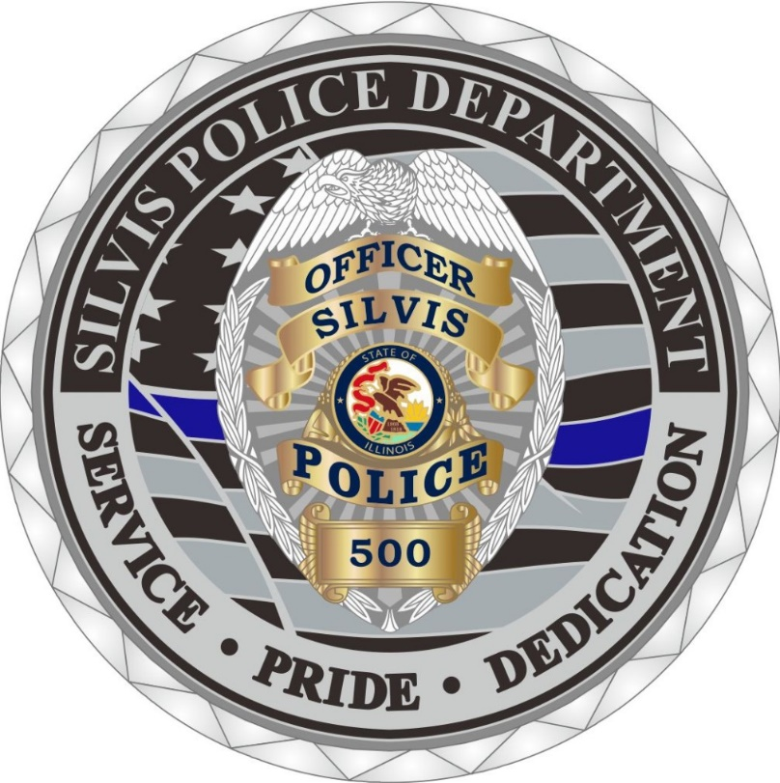 |  | The Silvis Police Department patrols a progressive city that takes pride in the Police Department. The Silvis Police are dedicated to public service with an emphasis on community oriented policing. In the last 40 years, the city has gone from 10 sworn officers to currently having 17. Police Officers are the backbone of a community and stand guard over its citizens. We take pride in our police department and strive for transparency and demand the equal treatment of all. Currently, the Police Department consists of the following jobs and positions:  - Chief of Police  - Deputy Chief of Police  - Three (3) Sergeant positions  - Two (2) Detective Positions  - An undercover narcotics position  - Patrol positions  If you are looking for an exciting career that is both rewarding and challenging, this is the career for you. If you are looking for a noble way of life, something different every day, and challenges that reward the soul, step up and become a police officer. Now, once you have taken that step and dedicated yourself to public safety, you’ll need a way to pay the bills and invest in your future. For this, the City of Silvis Police Department offers a great benefit package including:  - Competitive pay, starting at $60,881.60 plus overtime.  - Police pension system, retire after 20 years and collect at age 55.  - 401a retirement plan.  - 457 retirement plan.  - Excellent medical, dental, and optical coverage.  - Work schedule is 5 days on, 2 days off; 5 days on, 3 days off; repeat.  - Member of the Illinois Fraternal Order of Police.  - Earn time off, including: vacation time, personal time, compensation time, and sick time.  - Earn educational incentive pay.  - Earn holiday pay.  - Uniform allowance.  

City Of Silvis Police Department
Service, Pride, and Dedication

CONTACT
Chief Mark VanKlaveren
309-792-1841

WEBSITE:
www.silvisil.org

EMAIL:
mvanklaveren@silvispd.org

